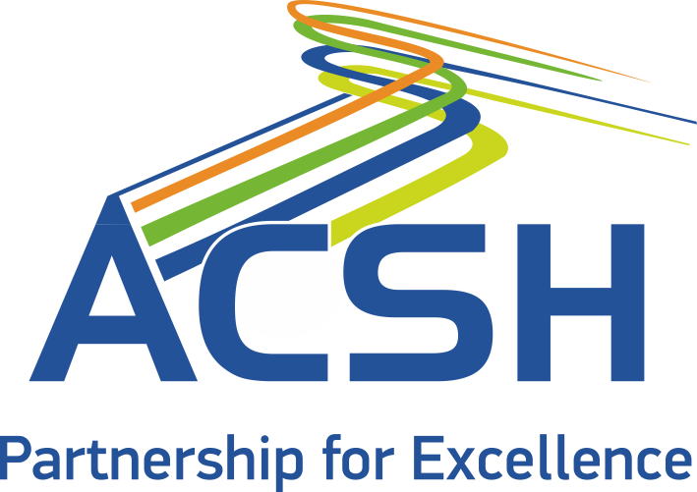
08
Fall
June
2018
Third Needs Assessment Survey of the ACSH Participating Countries

Results Report

Third Needs Assessment Report

A Needs Assessment survey among the ACSH participating countries is conducted every 2 years. The first assessment - baseline study - was carried out in 2013, when the ACSH was first founded, to establish priority areas for the project. Two years later, in 2015, the second Needs Assessment Survey among the ACSH participating countries was also carried out.

On 16 April 2018, the Astana Civil Service Hub (ACSH) launched its third Needs Assessment survey, which was open to potential respondents until the end of May 2018. The Survey was conducted online and comprised of 11 questions.

Invitations to participate in the third Needs Assessment survey were sent to potential respondents in participating countries and organisations. By 31 May, 19 responses were registered in the electronic survey platform, translating to a 36% response rate.
The findings of the third Needs Assessment survey provide sufficient information to discern the priority areas of cooperation in civil service management and development and in public service delivery for the next two years. It gauges interest for potential activities supporting civil service development and public service delivery enhancement.
Question 1: It attempts to capture the views of respondents on how the ACSH has responded to research and capacity building interventions since the second Needs Assessment survey was completed in 2015.
31,6% of respondents consider ACSH research and capacity building interventions relevant to their needs and expectations, and 15,8% of respondents replied that they are slightly relevant. The results indicate that the mix of activities is relevant and congruent with the needs of the participating countries.

In other words, the ACSH has delivered well on the key priorities identified in the second Needs Assessment survey, as the research and capacity building interventions of the ACSH have proven to be very relevant and rather efficient in fostering regional cooperation and disseminating good practices across the participating countries.
Question 2: It tries to capture the views of respondents on whether the ACSH interventions have been efficient in fostering regional cooperation.

Question 3: It tries to find out what type of activities respondents would be most interested in the period ahead. Respondents were provided with 6 choices, of which they could pick at least 3 of the most important topics to them. The results are presented below in order of preference, from the most to the least popular.
Ranking | Topic | Average of preference scores  (max 5)
1 | Implementation of joint programmes and projects | 4.47
2 | Participation in foreign trainings and seminars for capacity development | 4.43
3 | Acquisition and dissemination of knowledge of current trends in the development of the civil service in the region | 3.73
4 | Development of the institutional structure for knowledge and experience exchange | 3.65
5 | Utilisation of the Hub’s research results in global and regional trends in civil service and public administration reform for implementing reform in your country | 3.11
6 | Maintenance and enhancement of the Hub’s Experts Network | 2.31

Implementation of joint programmes and projects is the most popular topic. Participation in capacity development activities abroad is second and knowledge dissemination of current trends in the development of civil service is third.
It should be noted that preferences of the participating countries about the types of activities have remained constant over the past 3 years, as the previous Needs Assessment surveys have yielded very similar results.
One significant change noted since the last Needs Assessment survey is that “Utilisation of the Hub’s research results in global and regional trends in civil service and public administration reforms” scores higher than the “Maintenance and enhancement of the Hub’s Experts Network”. This can be easily explained since, in 2016, the Hub published the “Global and Regional Trends in Civil Service Development”, which has become one of the most demanded publications among participating countries and partners.
Question 4: It hopes to discover what forms of collaborative activities the ACSH should develop for encouraging active and continuous cooperation among its participating countries. Respondents were provided with 9 choices, of which they could pick the 5 most important to them. The results are presented below in order of preference, from the most to the least popular.
Ranking | Topic | Preference frequency
1 | Joint trainings / seminars | 19
2 | Thematic roundtables | 14
3 | Regular consultations and meetings on topics of mutual interest | 13
4 | Exchange of information through on line platforms | 12
5 | Cooperation with the Hub’s network of experts | 11
6 | Joint scientific research | 10
7 | Team building through the conduct of events abroad | 9
8 | Webinars on a regular basis | 5
9 | Online forums dealing with specific issues through professional social networks | 4

For comparison purposes, here are responses for the same questions from the 2015 survey.

When the results are compared, it appears that team building through the conduct of events abroad, webinars and online forums remain the least popular forms of collaborative activities. The most significant difference between the responses for this question in 2015 and 2018 is that interest in thematic roundtables has increased over the past period.
Question 5: It expects to identify the topics of interest for capacity-building events. Respondents were provided with 15 choices and were asked to pick the
5 most important and most relevant to their work. The results are presented below in average scores calculated as a weighted average and the response count.
Ranking | Topic | Score
1 | Civil servants' performance appraisal system (individual performance) | 10,62
2 | Improving public service delivery | 10,57
3 | E-government and the use of ICT in the public sector | 10,4
4 | Competencies and skills for a high-performing civil service | 9,6
5 | State bodies' performance appraisal (organizational performance) | 9,29
6 | Civil servants' motivation and work performance | 9,07
7 | Talent management and career development | 8,62
8 | Ethics and integrity in civil service | 8,6
9 | Leadership in public administration and civil service | 8,6
10 | Project management in civil service | 8,5
11 | HR management in civil service | 8,21
12 | Corruption and accountability, anti-corruption policies | 7,88
13 | Grading and remuneration in civil service | 7,67
14 | Recruitment and selection process of civil servants | 6,36
15 | Gender equality in civil service | 4,79

Top 5 priority areas for capacity-building events include (1) civil servants’ performance appraisal system, (2) improving public service delivery, (3) E-government and the use of ICT, (4) competencies and skills for a high-performing public sector, and (5) state bodies’ performance appraisal system.
For comparison purposes, in 2015, priority topics for trainings and/or seminars were (1) effective human resources management, (2) anti-corruption policy, (3) professionalism and ethics in civil service, and (4) motivation and compensation of civil servants.
Question 6: Respondents were given the opportunity to suggest additional topics of interest for capacity-building activities. It was proposed by several respondents to organize trainings and workshops on innovation in civil service and, in particular, focusing on skills needed for digital government, analysis of big data, strategic thinking, nudge theory and behavioural economics. Respondents also proposed such themes as transfer of services to civil society and business and disaster management.
Question 7: As in Question 5, this question tries to identify the topics of interest in research. Respondents were provided with 15 choices and were asked to pick the 5 most important and most relevant to their work.
Ranking | Topic | Score
1 | Improving public service delivery | 11,17
2 | E-government and the use of ICT in the public sector | 10,57
3 | Talent management and career development | 10,46
4 | Organisational performance appraisal | 10,31
5 | Ethics and integrity in civil service | 9,93
6 | Civil servants' performance appraisal system (individual performance) | 9,83
7 | Civil servants' motivation and work performance | 9,38
8 | Leadership in public administration and civil service | 8,93
9 | Competencies and skills for a high-performing civil service | 8,83
10 | Project management in civil service | 8,07
11 | Grading and remuneration in civil service | 8
12 | HR management in civil service | 7,54
13 | Corruption and accountability, anti-corruption policies | 7,5
14 | Recruitment and selection process of civil servants | 7,25
15 | Gender equality in civil service | 6

(1) Improving public service, (2) E-government and the use of ICT, (3) talent management and career development, (4) state bodies’ performance appraisal, and (5) ethics and integrity seem to be the most popular topics.
It should be noted that priority areas for research and capacity-building activities are quite similar. At the same time, priority topics reflect current trends in civil service reform and development.
For comparison purposes, in 2015, the most popular topics for research were (1) effective human resources management, (2) professionalism and ethics in civil service, and (3) quality and public service delivery.
Question 8: Respondents were asked to suggest additional topics of interest for the research agenda. Some of the proposed topics are similar to those proposed for capacity-building events. Groups of additional topics suggested for inclusion in the research agenda are given below:
- Brain leak from civil service
- Disaster management
- E-Government and disruptive technologies
- Innovation in civil service
- Policy making - cooperation and coordination of the process
- Civil service values
- Meritocracy
- Nudge theory, behavioral economics
- Urban planning
- Smart city
- Analysis of big data
It should be noted that E-government is the most popular topic throughout the survey. Although e-government is given in the list of topics in Questions 5 and 7, respondents propose it as the additional topic, when they are provided with the choice to do so. It is also one of the top 3 priority topics both for capacity-building events and for the research agenda.
This interest of participating countries in e-government is already reflected in the Hub’s activities. The Innovative Solutions Scheme in 2018 is focused on Digital Government Solutions. The second Peer-to-peer Learning Alliance is devoted to the E-governance issues, too.
Question 9: This question intended to capture the respondents’ views on the quality and content variety of the Hub’s Journal.
13 out of 20 respondents expressed no view on the quality and content of the Journal. 2 expressed a positive view and had nothing to add. Some respondents suggested that there should be two types of articles: one traditional scientific papers, and the other is short articles. Another suggestion was to engage young public servants to publish their articles and research activities. Some respondents suggested to have more articles on the experience from European countries.
Question 10: It intended to capture the views of respondents on whether the ACSH website is relevant, informative, and timely.
The overall impression is that the content is timely, relevant and informative, however there is a room for improvement. Comments regarding the website were received in the Question 11.
Question 11: It intended to elicit the views of respondents in relation to the website content.
Some respondents suggested that the website could contain news on significant events from participating countries in the field of the civil service. The website currently contains country profiles on civil service and public administration systems and focuses mostly on the joint events.
Another suggestion was to have more infographics and videos on the website.
Some other respondents suggested to add "subscribe" button for those who are interested to receive information regularly of the activities of ACSH. This button already exists on the website and it seems that it should be more visible to become effective.

The ACSH has published 10 editions of the Journal to date.

